A Jack is a male donkey
A Jenny is a female donkey
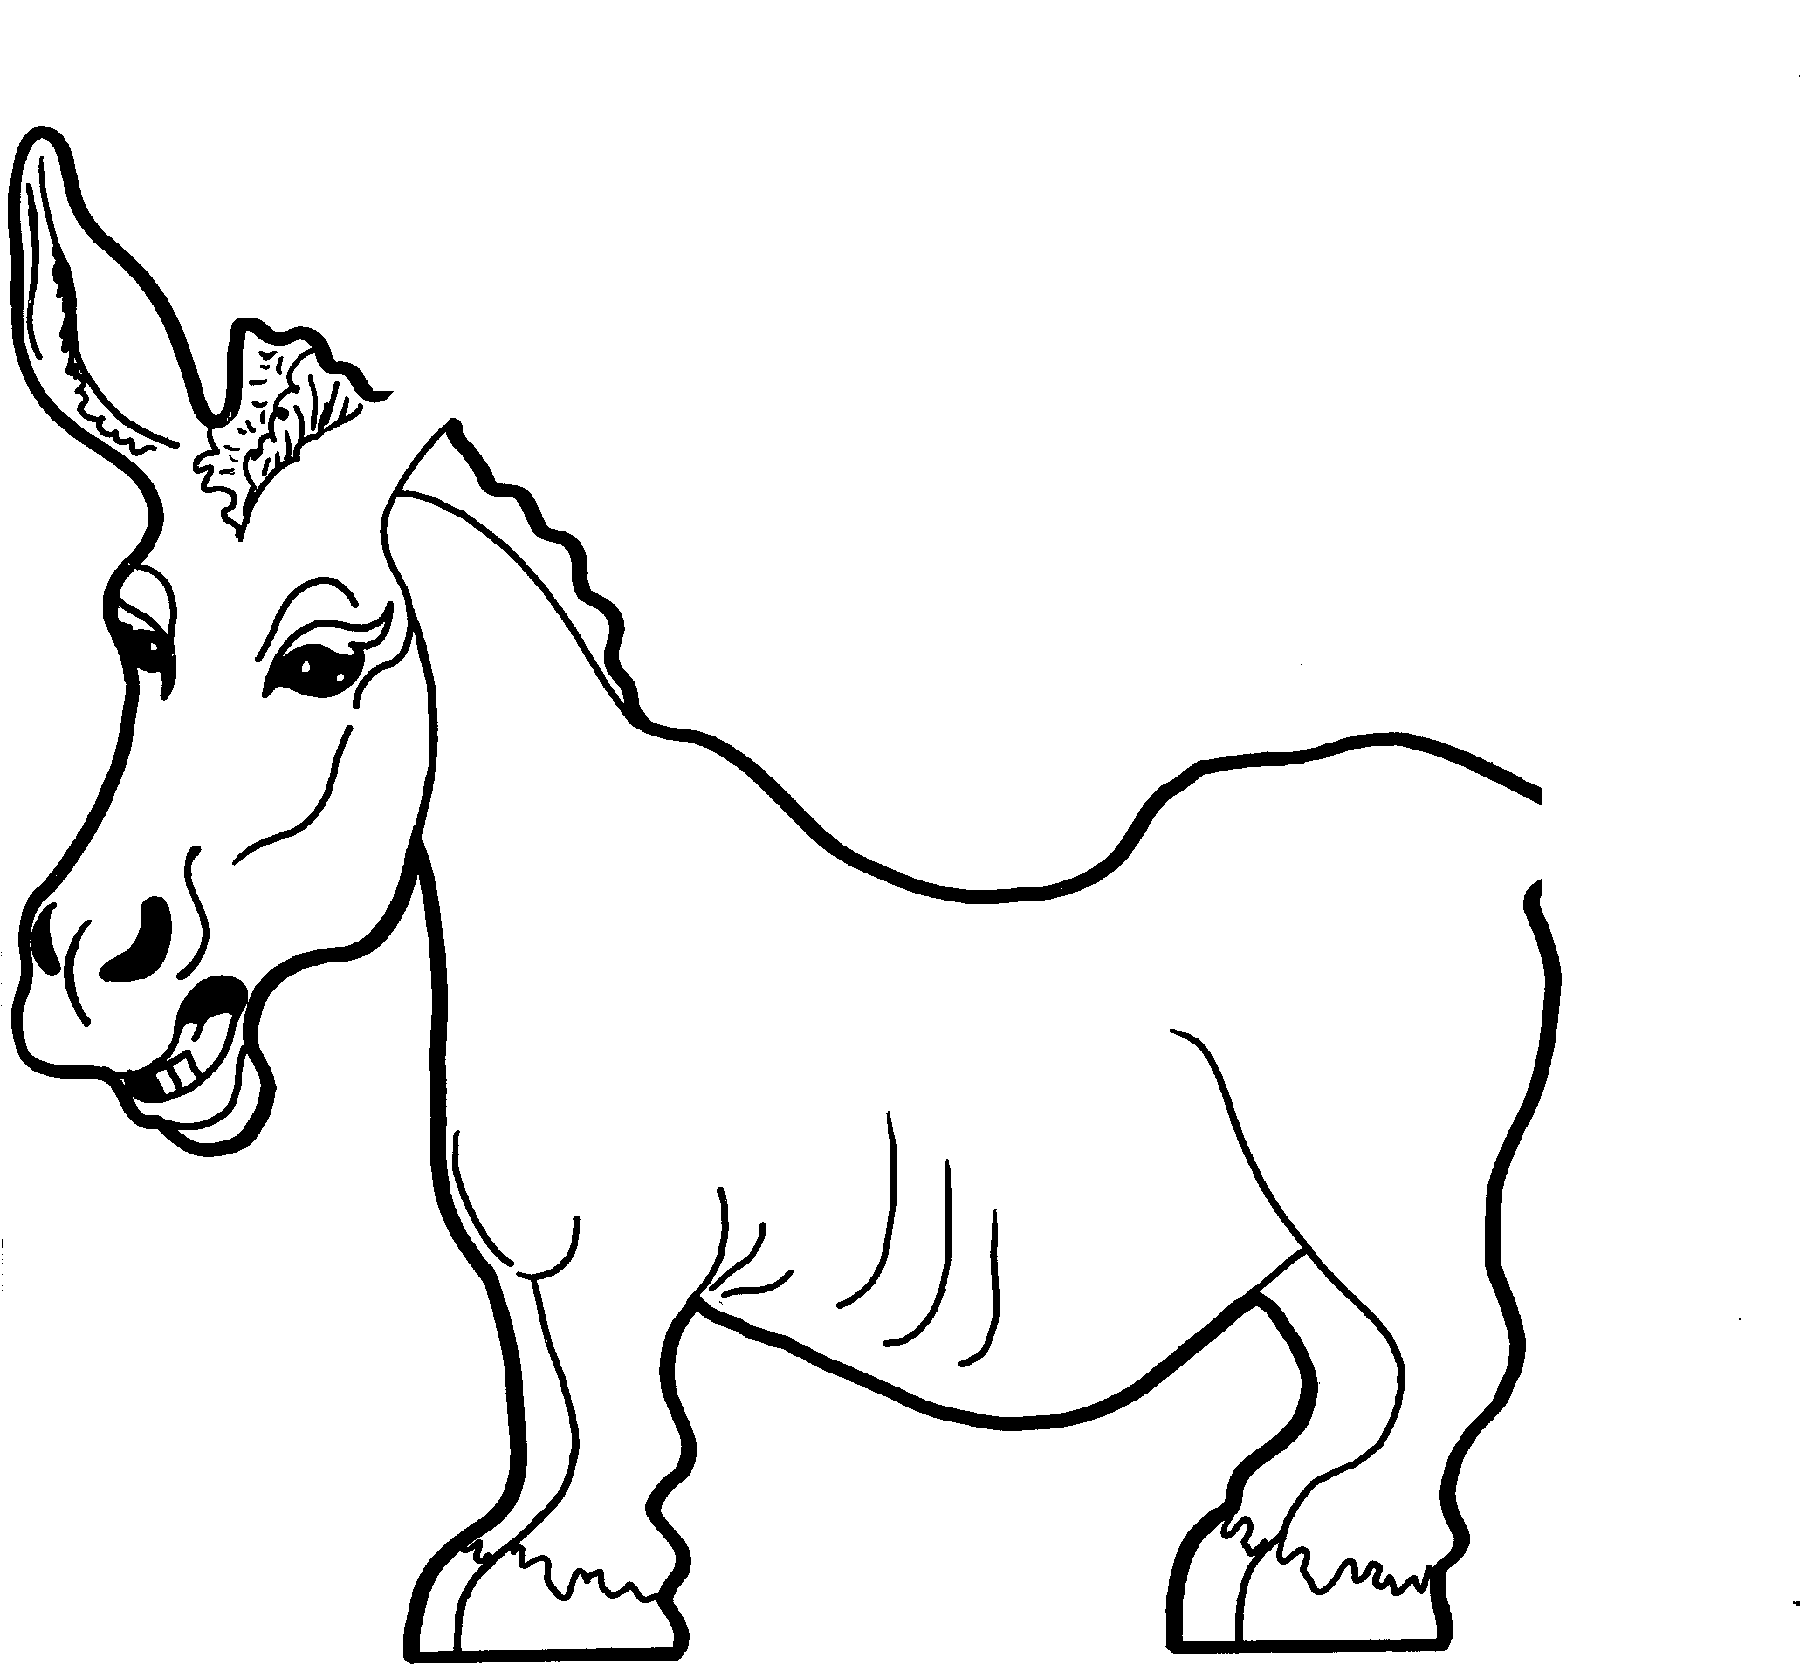
Can you finish the picture?

Our Miniature donkeys are registered. To be a mini they need to be less than 36” tall. They are strong and can carry or haul their own weight. A horse can only carry around a quarter of its weight. We will have babies for sale next summer. Our donkeys make great pets and are very smart and loyal.

